**Train Game**

This project will be a train simulation where a train goes along a path and tries to collect all the diamonds while attempting to avoid stars on the course. The user wins by collecting all the diamonds without colliding with any stars.

**Top down view of the scene**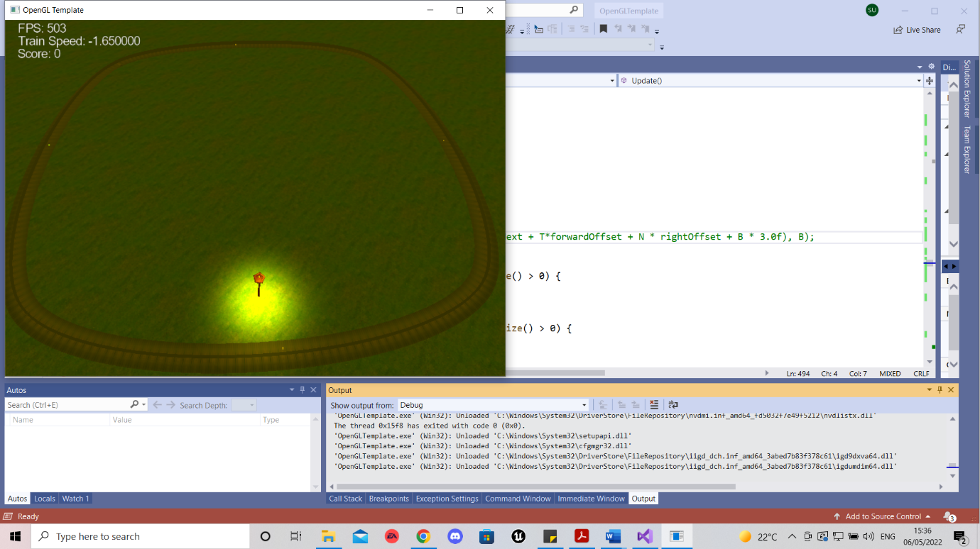

This scene shows the track with the consumables , meshes and light source implemented.

* 1. **All user interface (keyboard / mouse) controls.**

|  |  |
| --- | --- |
| * 1. Key | * 1. Function |
| * 1. W | * 1. Accelerate |
| * 1. A | * 1. Move left |
| * 1. S | * 1. Decelerate |
| * 1. D | * 1. Move Right |
| * 1. 1 | * 1. First Person Mode |
| * 1. 2 | * 1. Top Down view |

**Route**

Following the path starting guide I created a 3D non-linear centreline for my path, based on splines with C1 or higher continuity. Then I created a quad shape using triangular primitives to form the path, ensuring the texture coordinates and normals are correct. Then I added train a track texture to the track and ensured the texture would loop correctly.

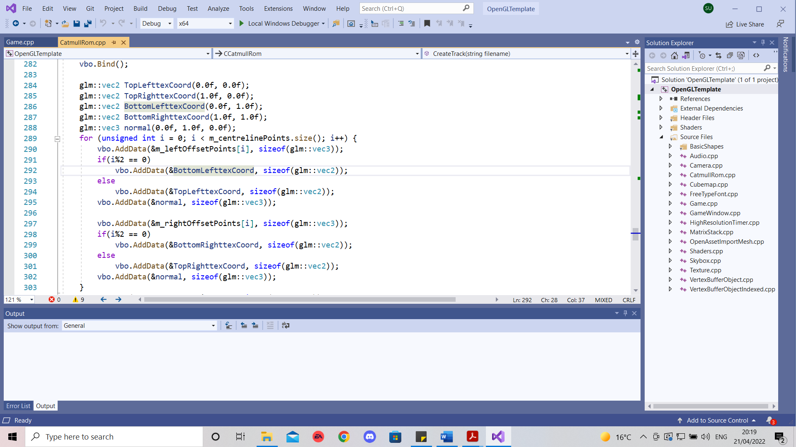

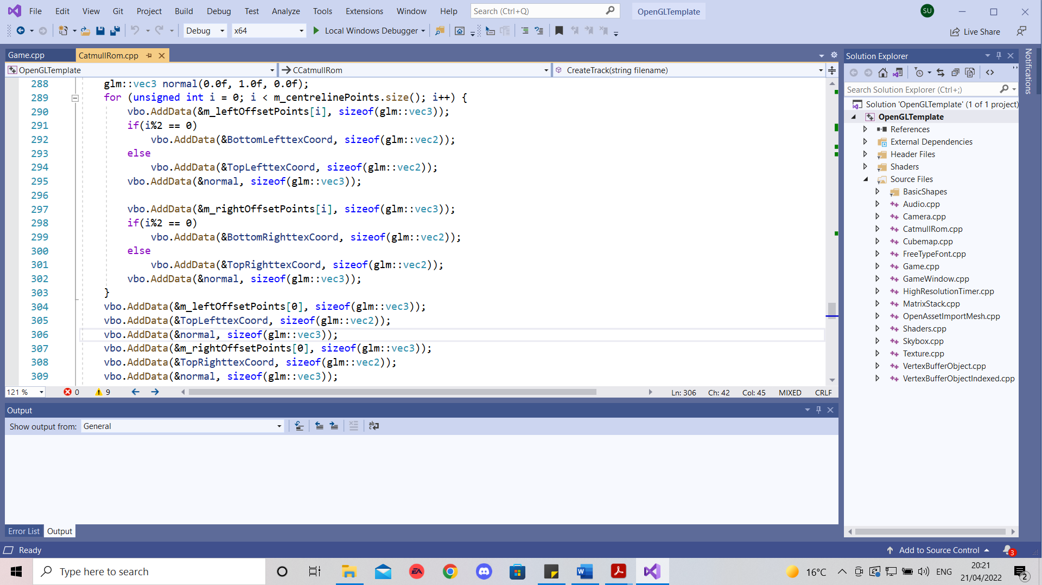

**Camera / viewing**

One of the camera angles I used was the first person which was placed right in front of the train. To achieve this I created a TNB frame and ensuring all values are normalised. Also I defined the train location and orientation.

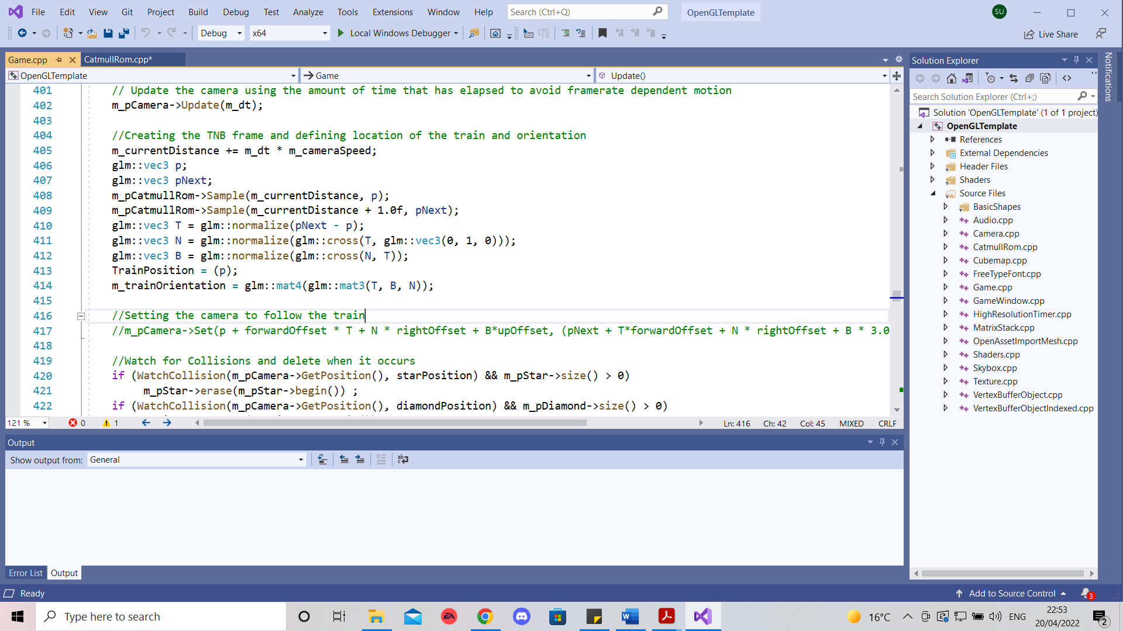

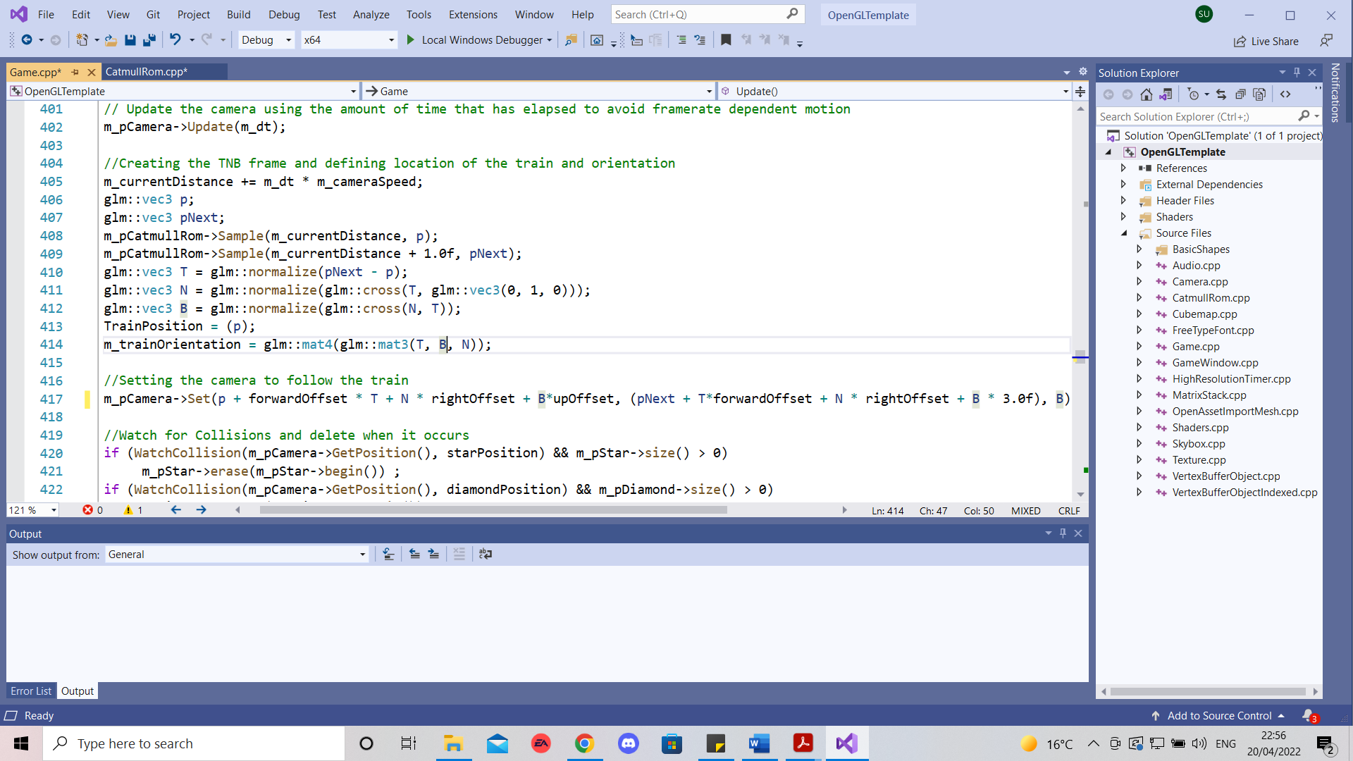Then I set the camera position , viewpoint and up vector

If the user were to press the ‘ 3’ key the camera would change to the top view. As I defined the forward, right and up offset globally I would change them accordingly, when the keys ‘2’ or ‘3’ are pressed.

* 1. **Basic objects**

One of the objects I used was the diamond from my Interim coursework which was rendered using GL_TRIANGLES. The other object was a 4 sided star.

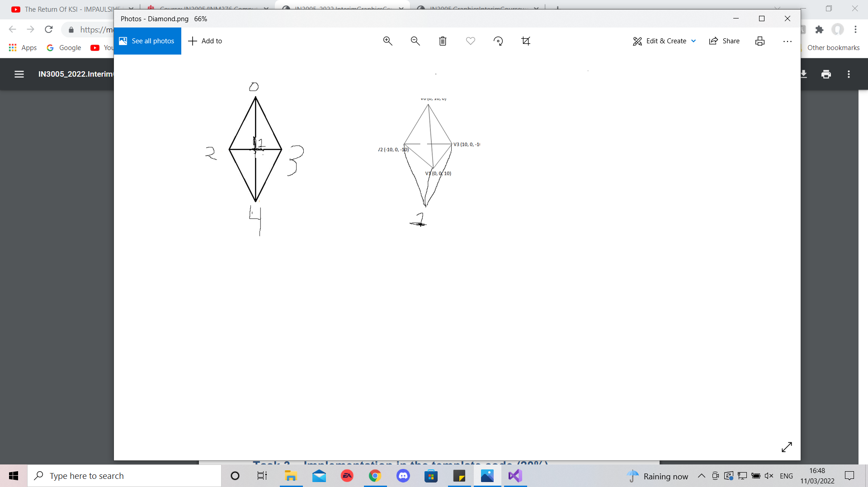

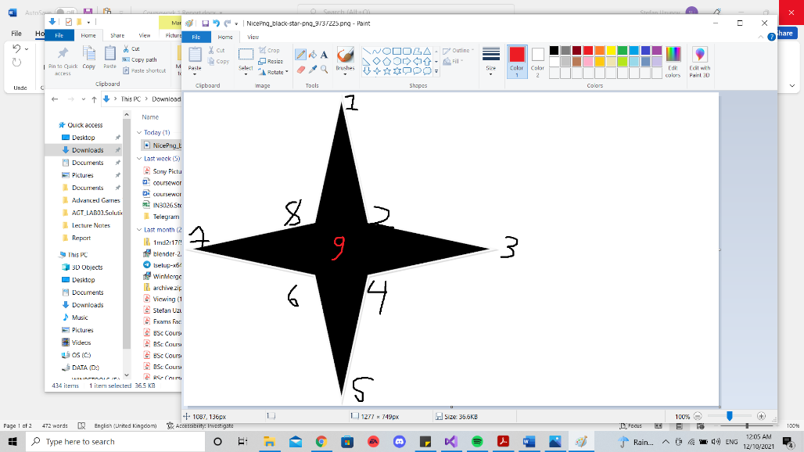

I then applied texture coordinates and normals for the star and diamond and rendered them across the track, ensuring they are appropriately positioned and oriented in the scene.

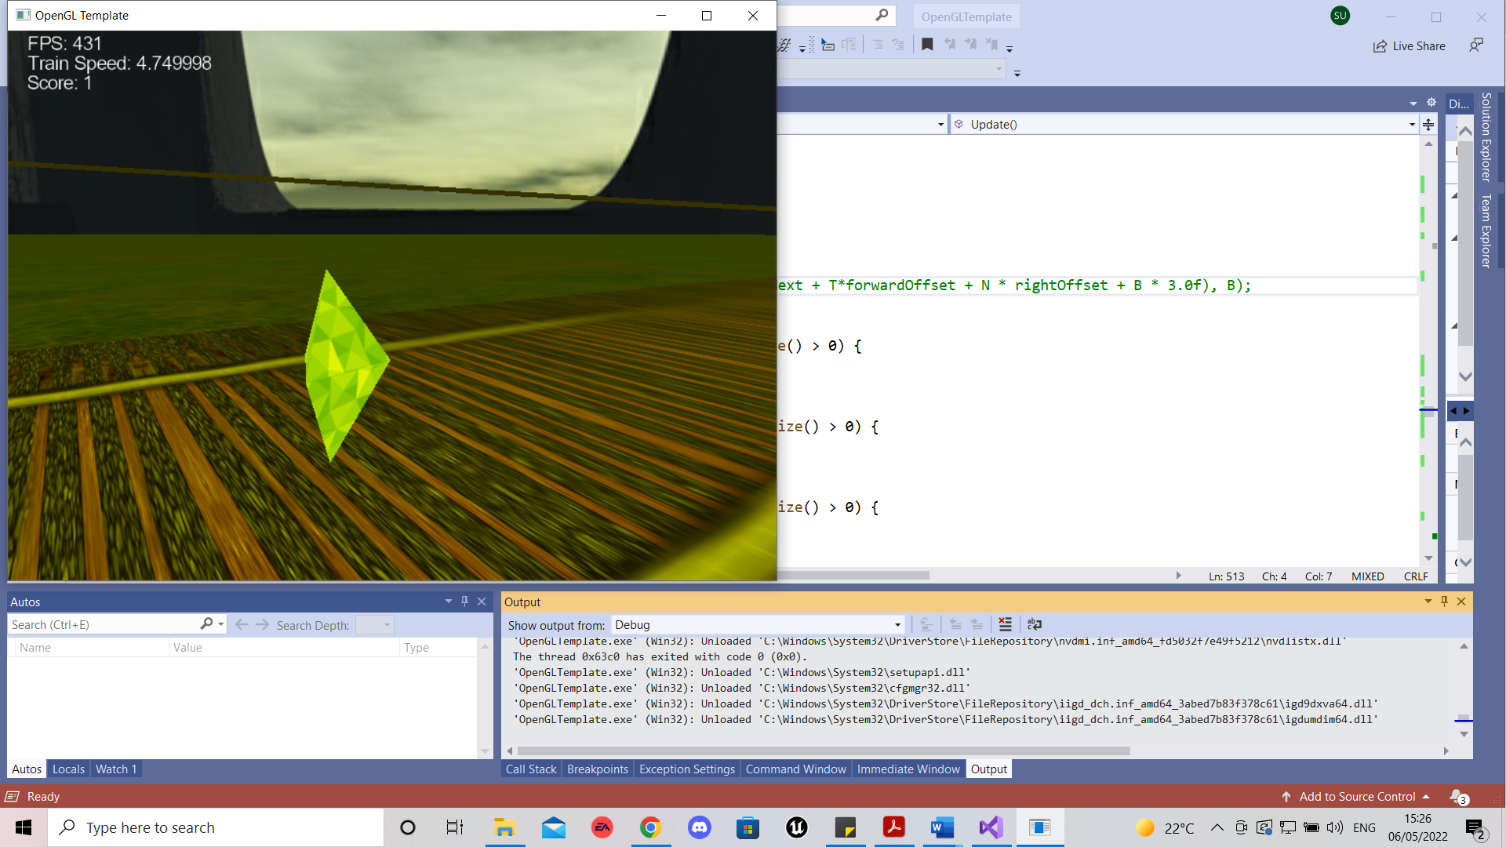

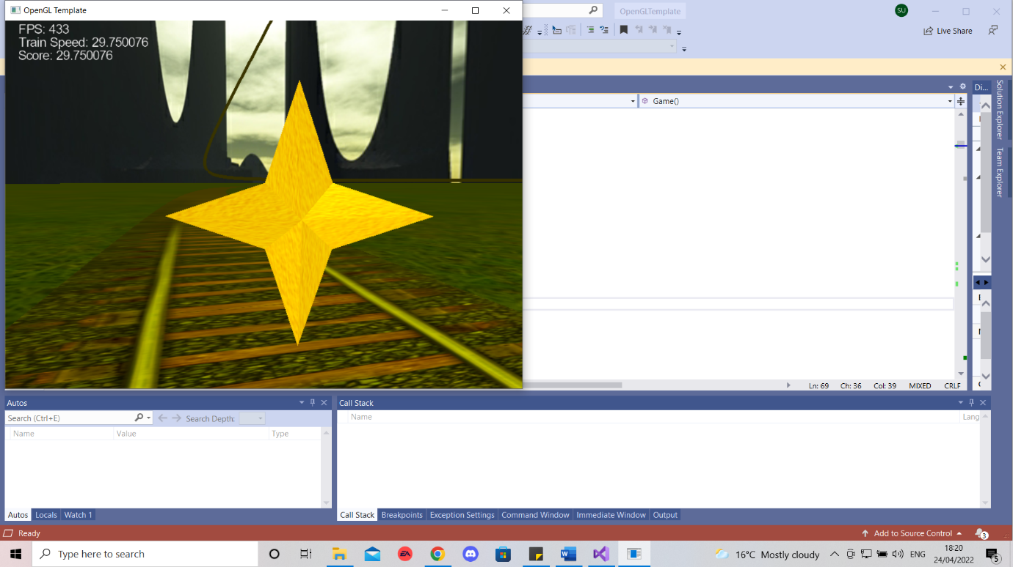

* 1. **Meshes**

The two meshes I have used are the train and a lamp

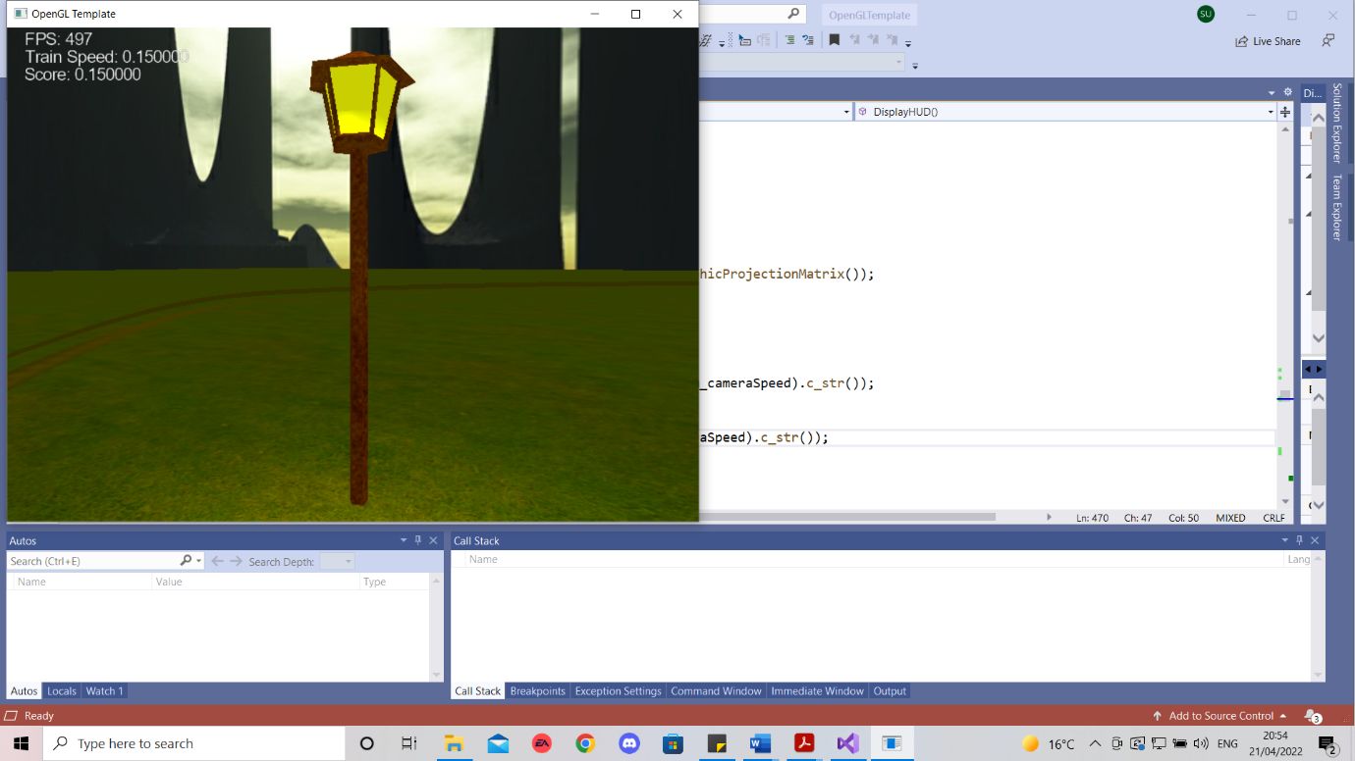

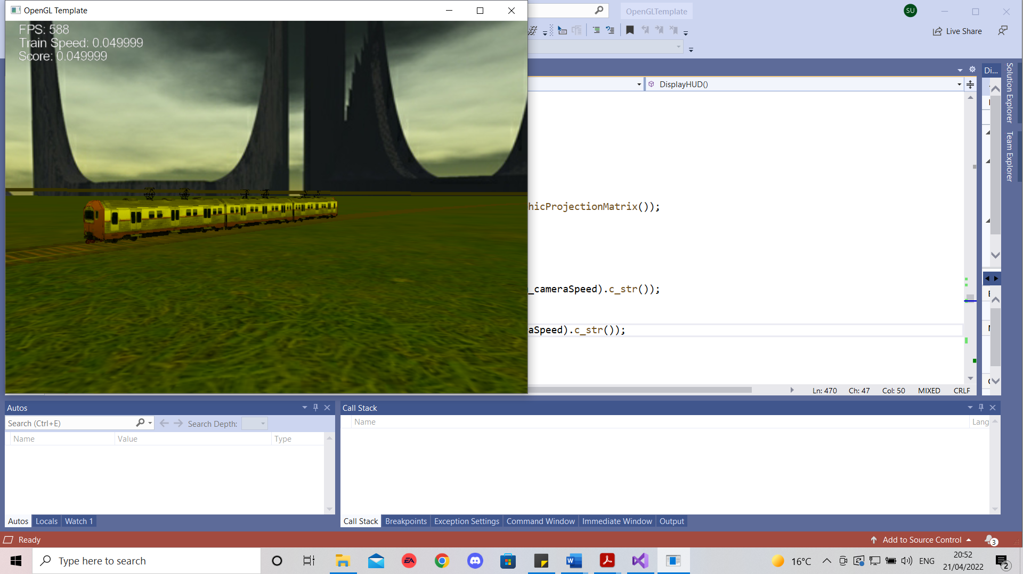

The train was positioned to always be on the track and move in the tracks direction and the lamp post was placed next to the track.

* 1. **Lighting**

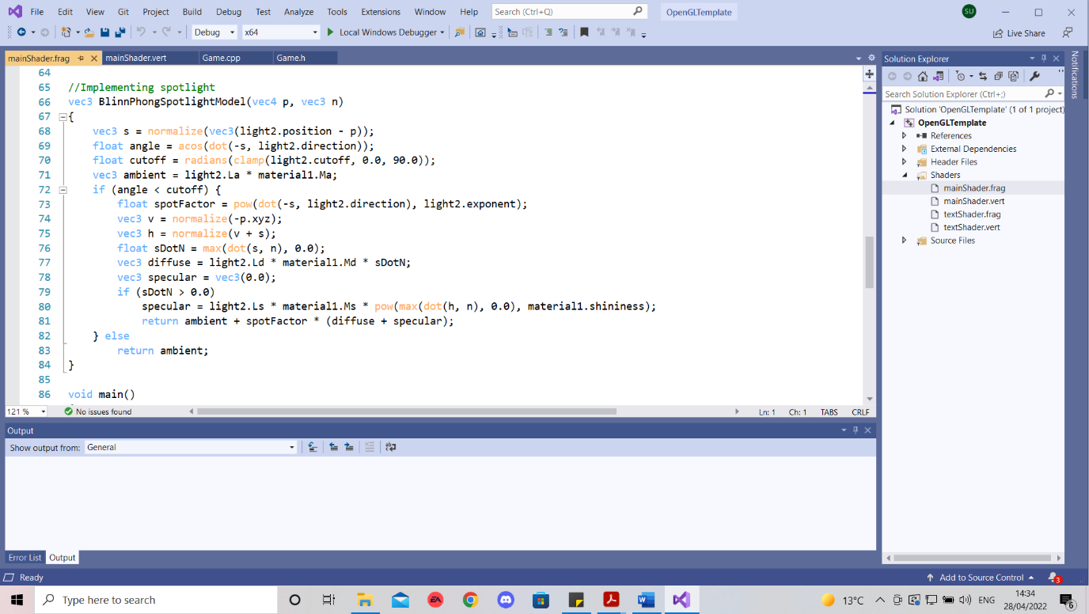A spotlight was implemented by using the Blinn Phong Spotlight Model . This was done by adding additional parameters to the LightInfo structure such as direction, exponent and cutoff. Then I called this model in the main of the fragment shader and passed these new parameters in the client program.

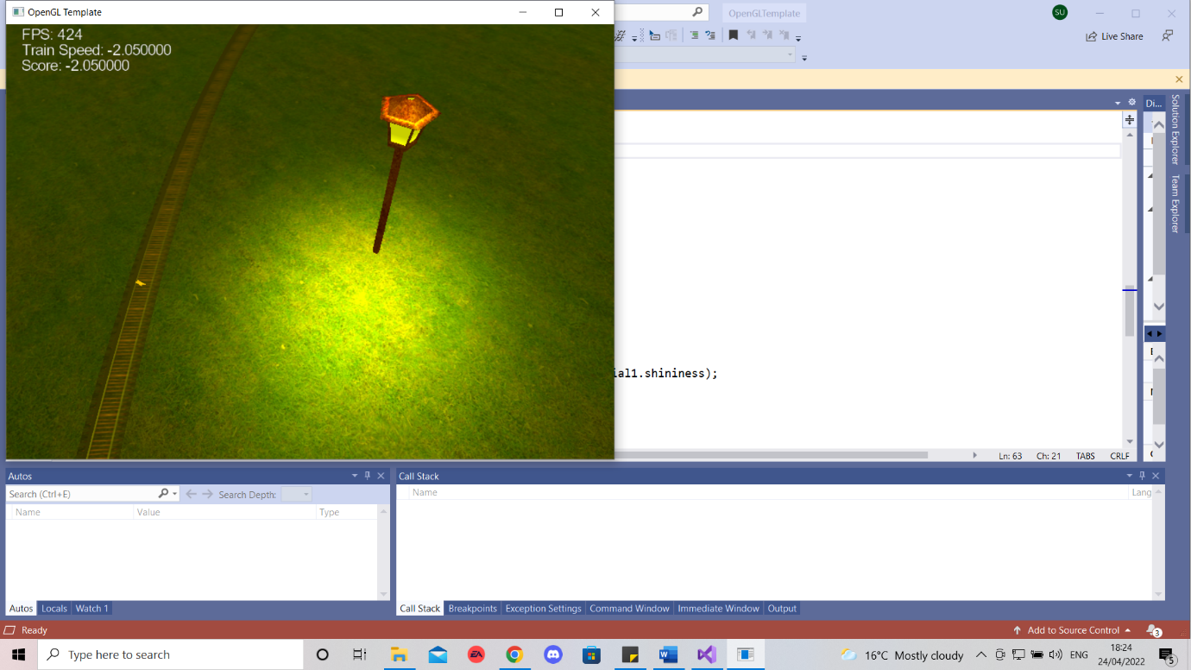

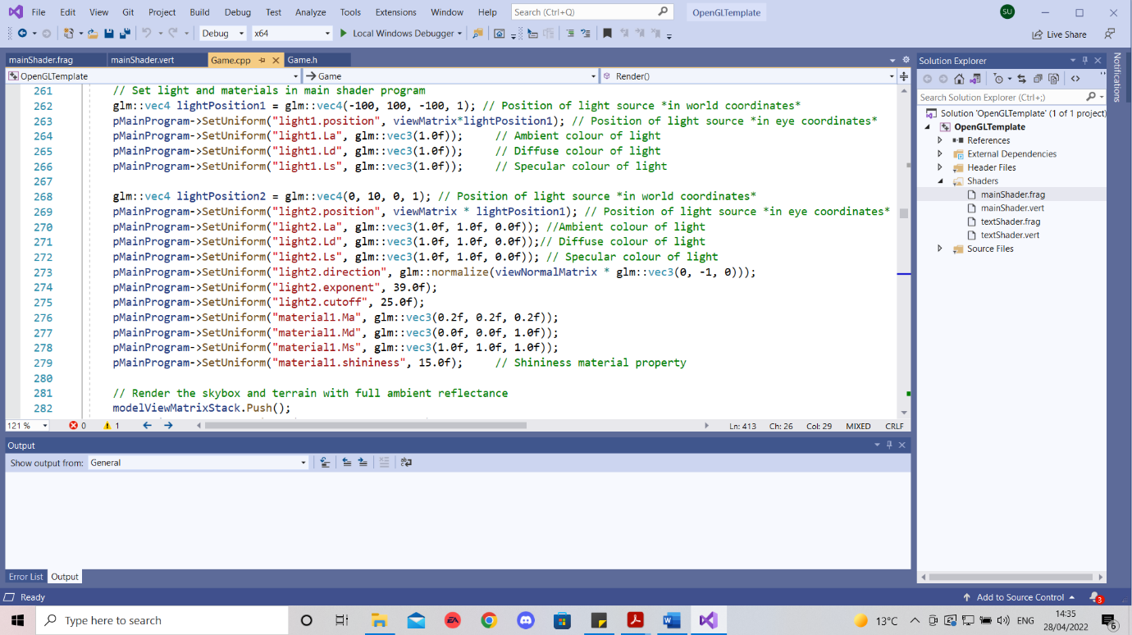

**Section 4**

* 1. **HUD**

My HUD contained the train speed and the score. Because the camera would follow the train the train speed and camera speed would be the same so I displayed the speed of the train on the HUD in the DisplayHUD method.

The score was also displayed on the screen along with a win and loss condition.

* 1. 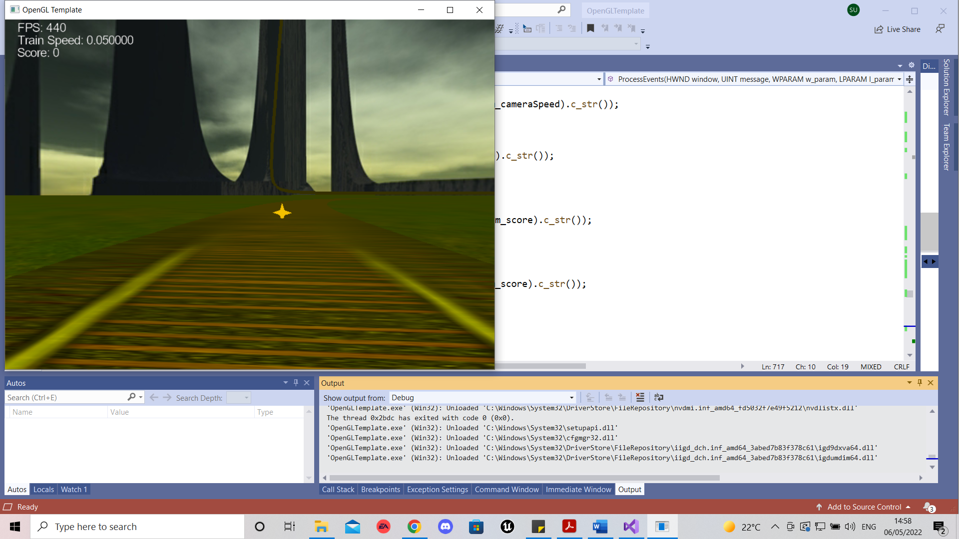

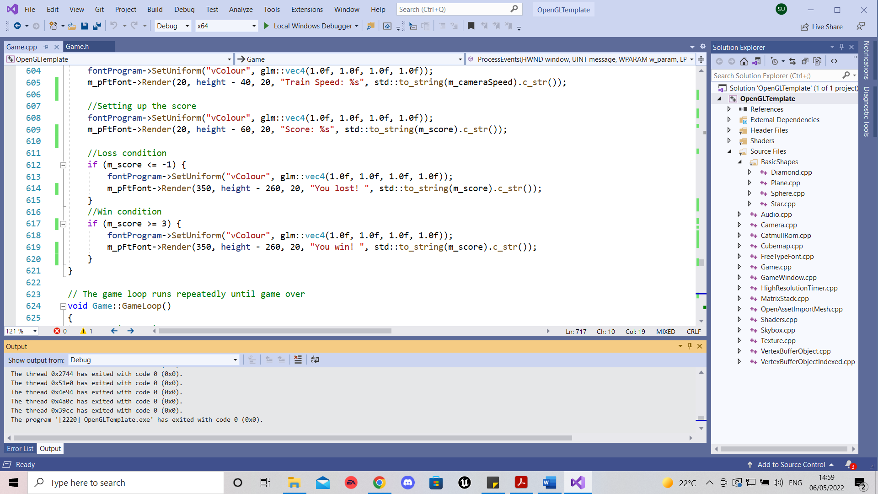

**Gameplay**

The aim of the game is to collect all the diamonds. However there are stars which upon collision would cause the player to lose the game. Each diamond gives 1 point while stars take away 4.

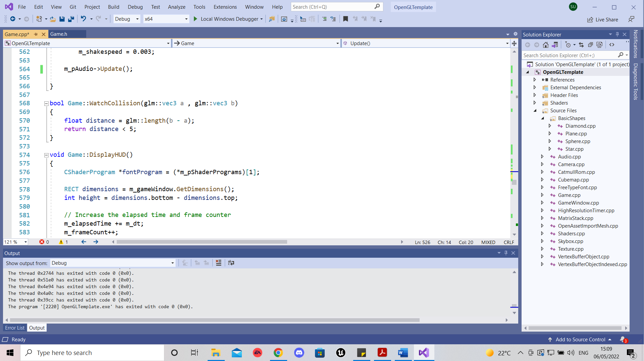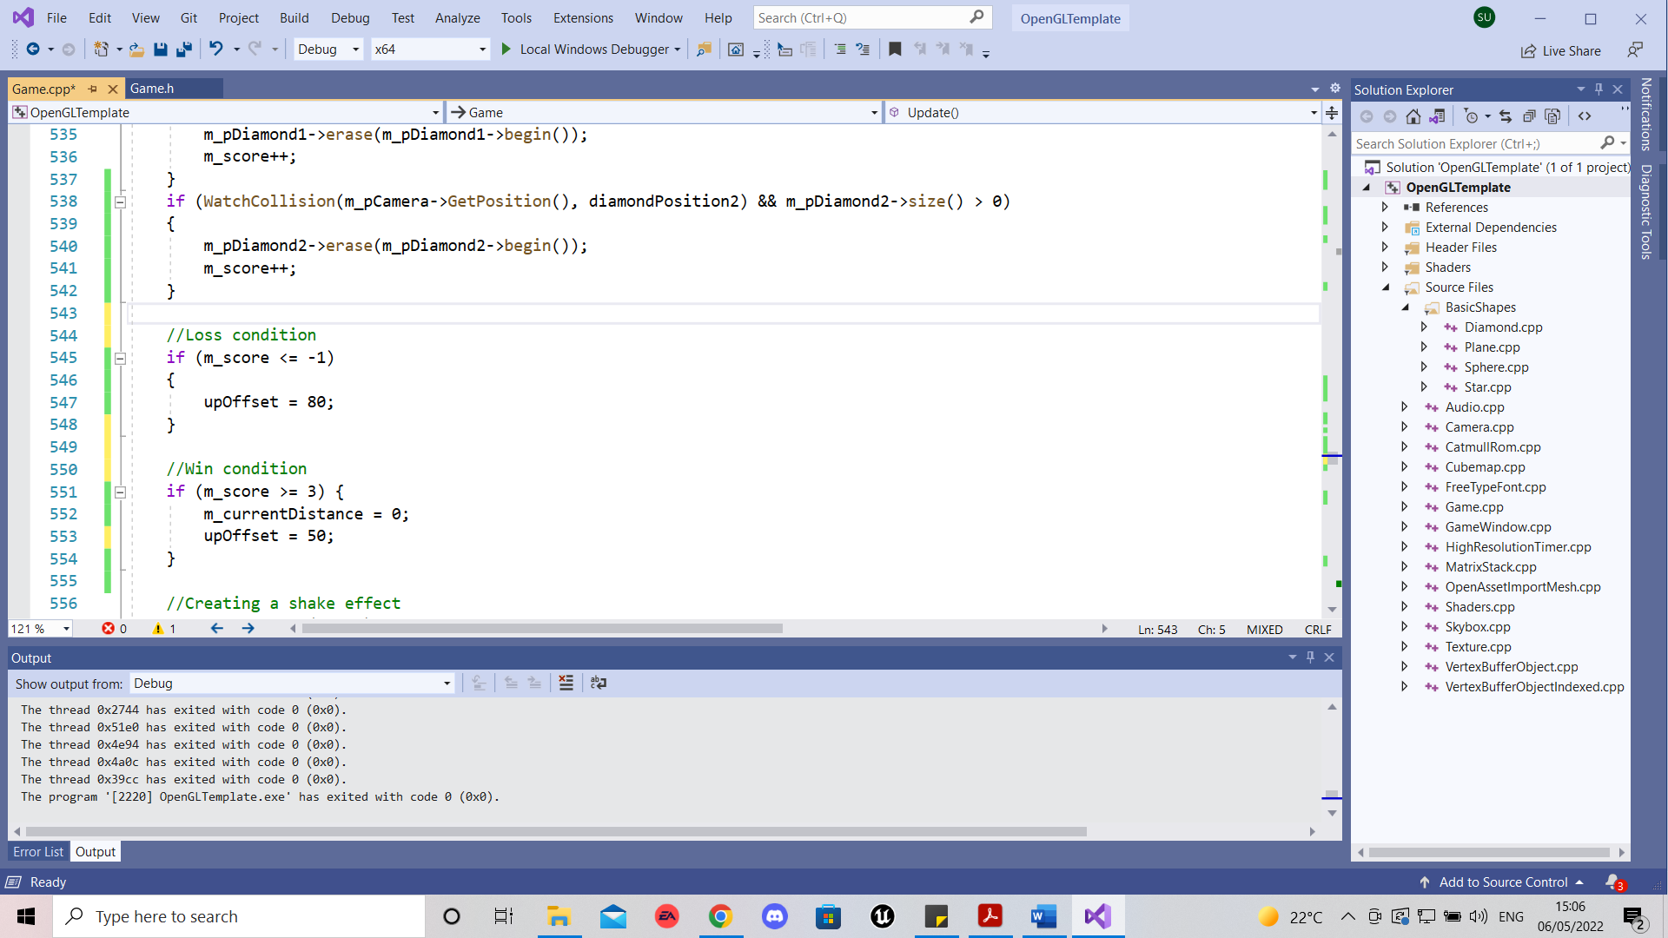

**Advanced rendering**

• Animation using discard in the fragment shader

The stars would disappear and appear to add a sense of surprise to the user as he is meant to evade them. To do this in the fragment shader I create a checkdiscard Boolean and set it to false. Then as I only wanted the star and nothing else to have the discard effect I set it to true for only the star object and false for everything else.

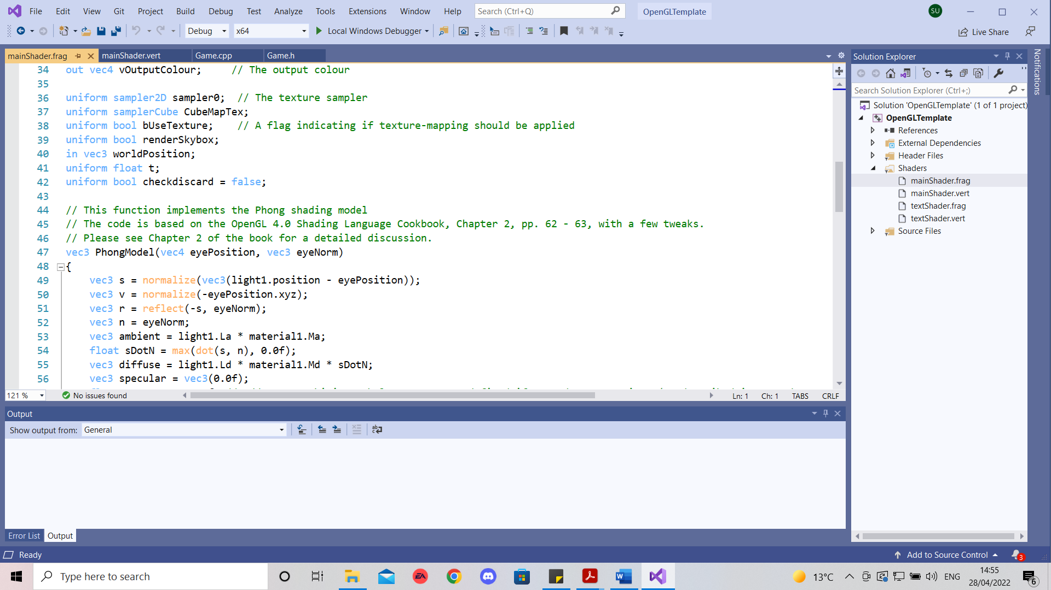

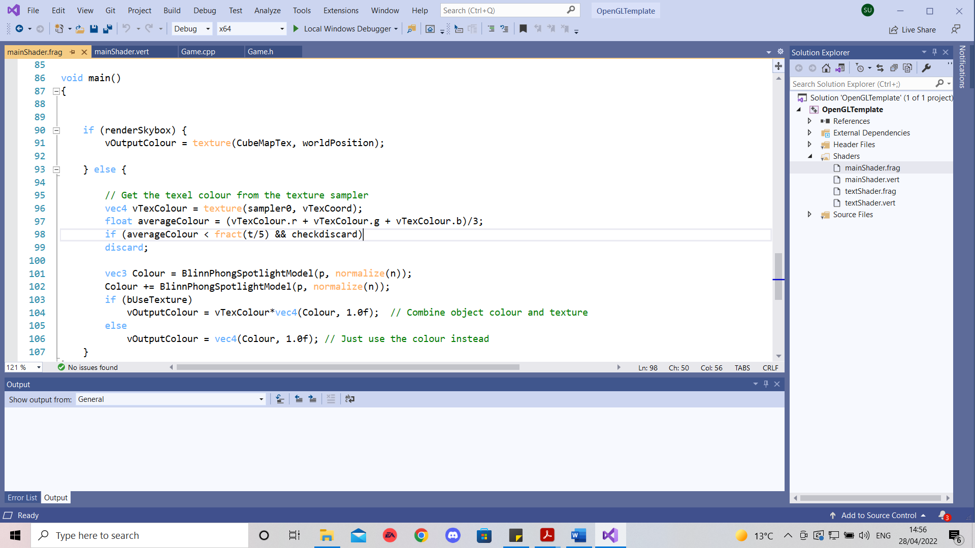

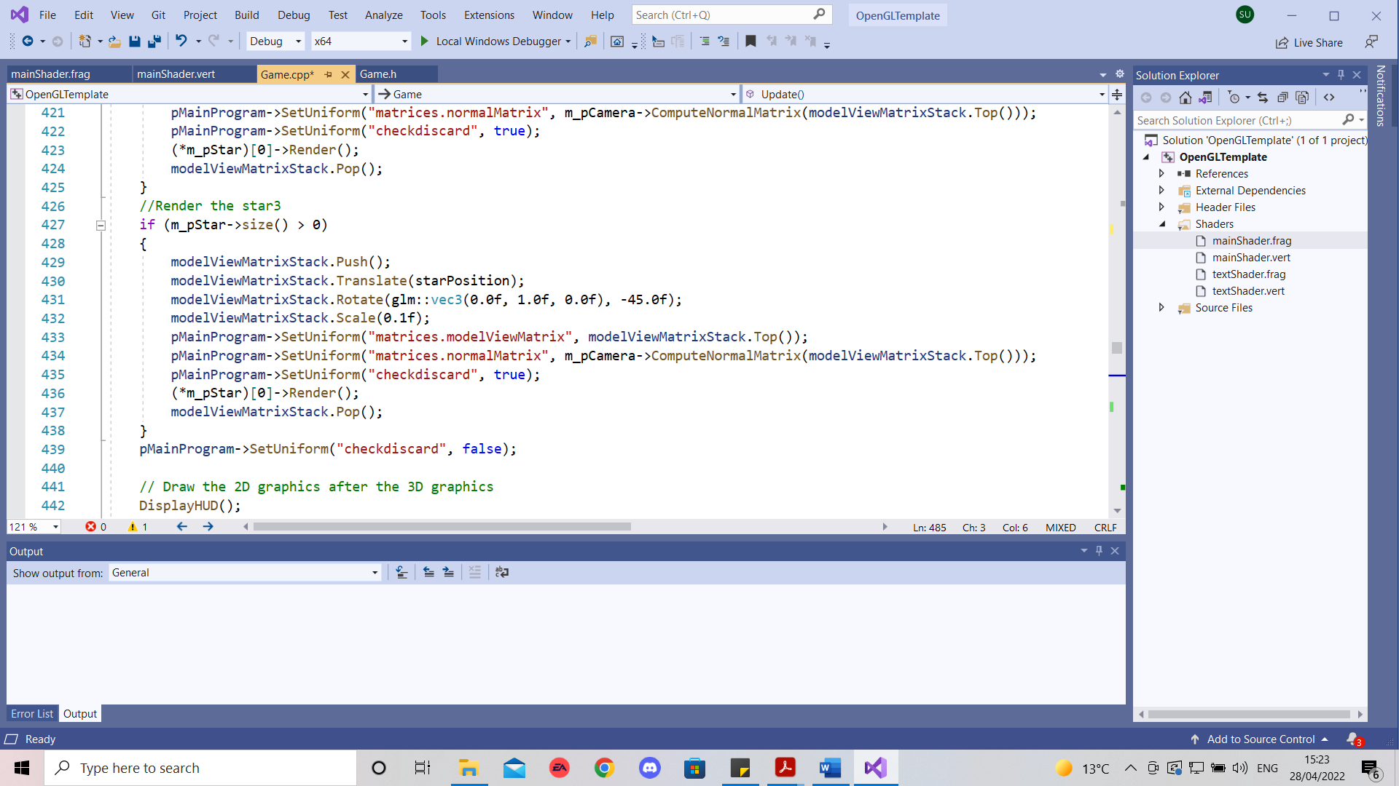

**Camera shake**

Vertex Shader

Creating m_shake and making sure the x and y coordinates are affected.

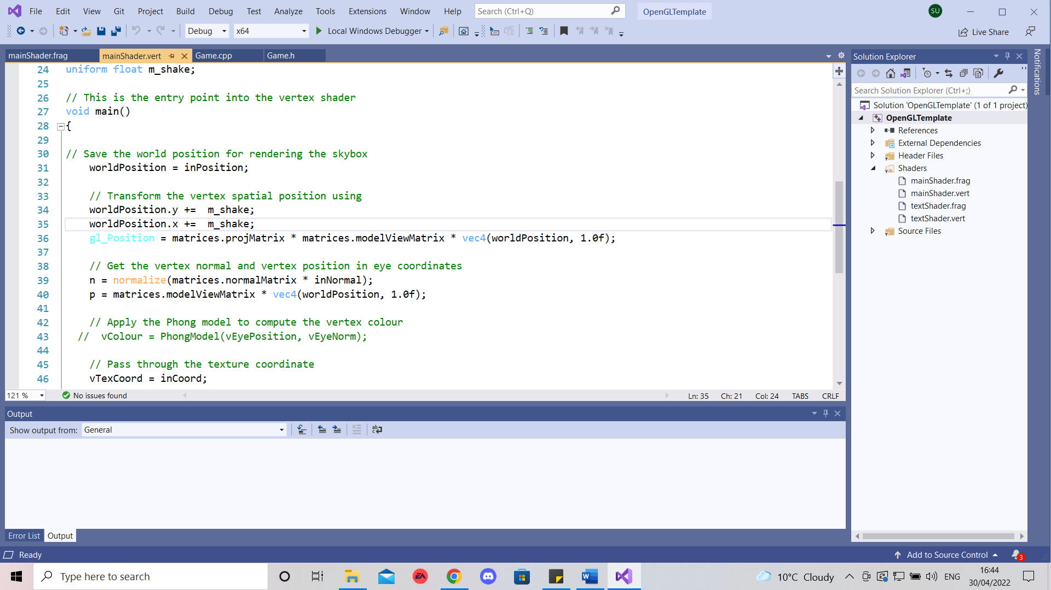

Client Side

Setting an if statement so the shaking occurs at all times but the value m_shake would constantly stay between 1 and 0 by adding and subtracting when it goes above 0 and adding when below 0 to keep them within that range.

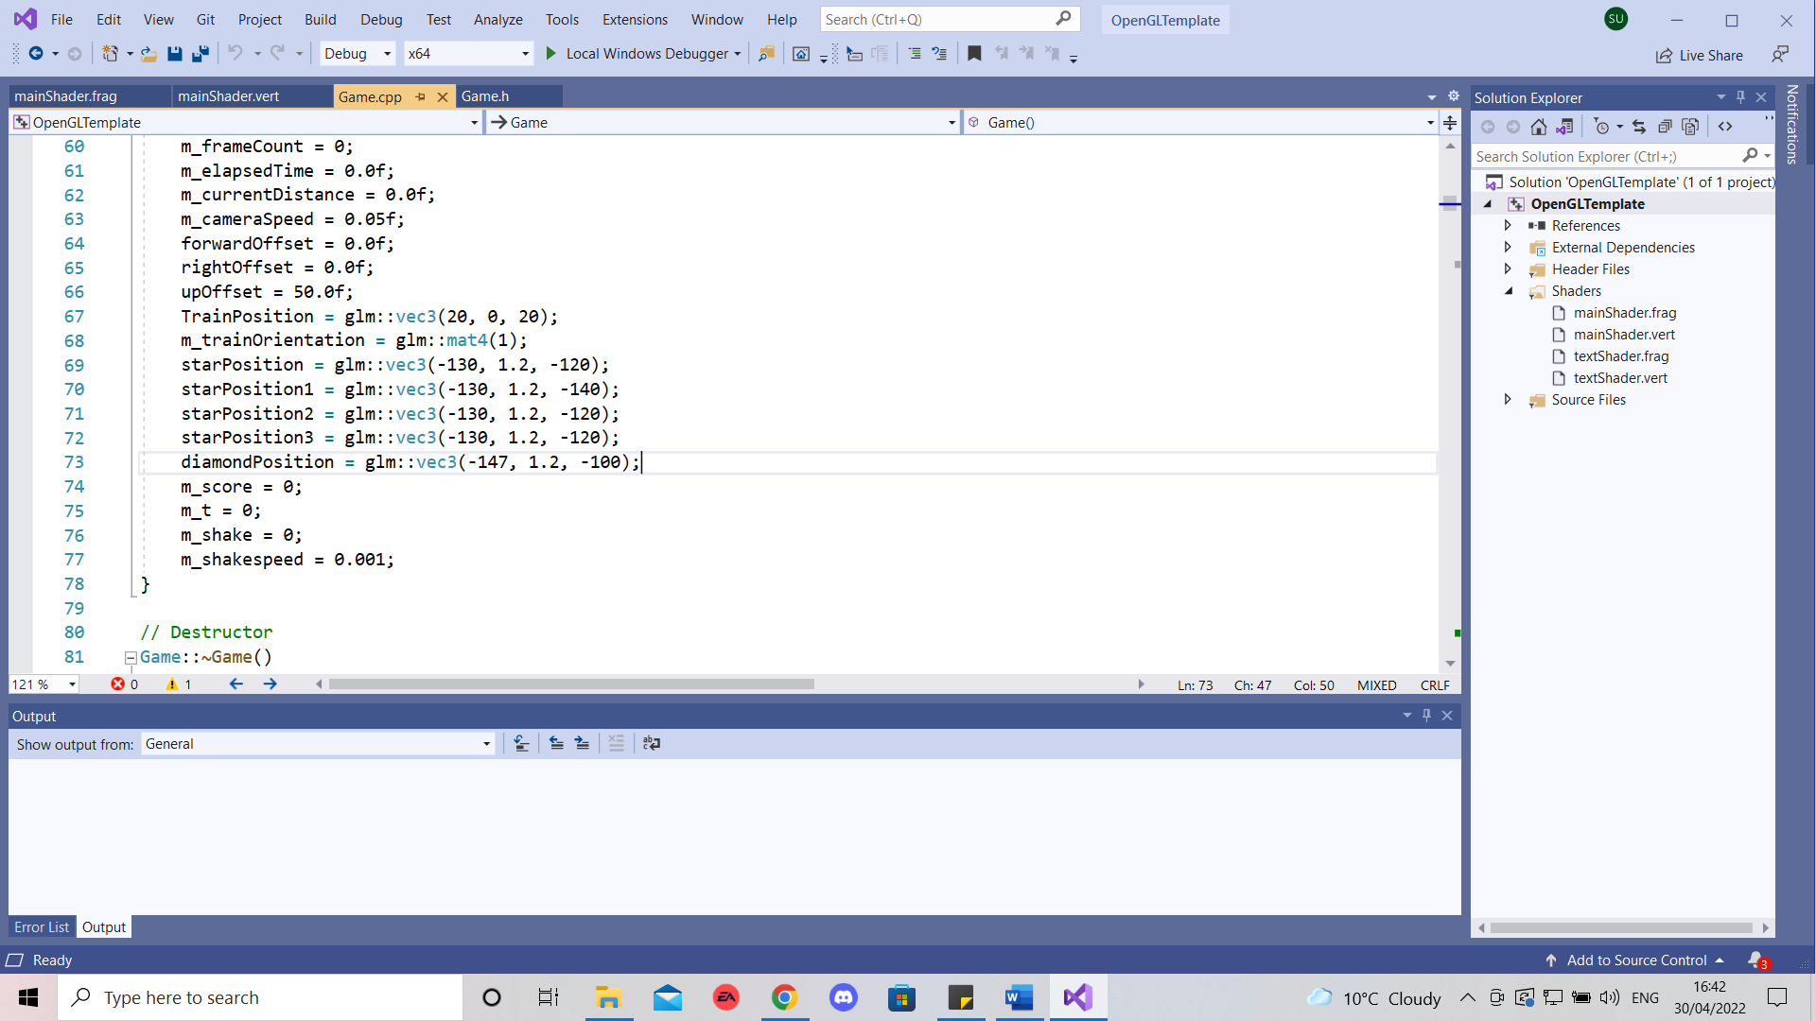

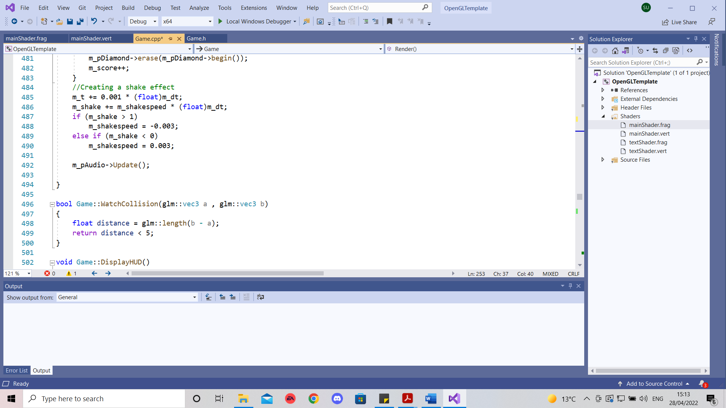

**Reflection**

My project has both strengths and weaknesses. One of the strengths would be the discard effect I added as it complements the gameplay mechanics , making it more challenging to play the game. As stars are meant to be evaded adding the fade effect adds to the tension as the player has to be constantly vigilant of his surroundings. As for the weaknesses the track would be one of them as it doesn’t go up or down and the shape of it is simple. To expand the project Into a more complete game I could have added different sounds/music and could have the train go through different terrains .

**Assets Listing**

**Train Tracks texture from** <https://opengameart.org/content/railroad-tracks>

Downloaded on 06/04/2022 , Free Licence

**Train Mesh from** <https://www.cgtrader.com/items/734199/download-page#_=_>

Downloaded on 01/04/2022, Free Licence

**Star texture** **from**

<https://www.freepik.com/free-photo/abstract-luxury-clear-yellow-wall-well-use-as-backdrop-background-> layout_1123107.htm#page=1&query=yellow%20texture&position=5&from_view=keyword

Downloaded on 02/04/2022, Free Licence

**Street Lamp Mesh from**

<https://opengameart.org/content/old-street-lamp>

Downloaded on 01/04/2022, Free License

**Diamond** **texture from** <https://www.rawpixel.com/image/1986/free-illustration-vector-diamond-geometry-texture>

Downloaded on 06/04/2022, Free License